**3. PROJECTS/MODULES COMPLETED**

**3.1. ABOUT MODULE 1**

**FIGMA**

**Introduction**

Figma is a powerful cloud-based design tool that has revolutionized the way designers collaborate and create user interfaces. It allows for real-time collaboration, making it an indispensable tool for modern design teams. This module delves into the core concepts of Figma, starting with the basics of the user interface and progressing to more advanced features.

Figma's collaborative nature streamlines the design process, allowing multiple designers to work simultaneously on the same project. This real-time collaboration significantly reduces design iterations and accelerates project timelines. Furthermore, Figma's prototyping capabilities enable designers to create interactive mockups, facilitating user testing and gathering valuable feedback early in the development cycle. The platform's extensive plugin ecosystem further enhances its functionality, offering a wide range of tools to automate tasks, generate content, and integrate with other design and development tools.

**Topics covered in Figma**

* **Introduction to Figma:** This section covers the fundamental aspects of Figma, including its interface, tools, and basic functionalities. It explains how Figma differs from other design tools and highlights its collaborative features.
* **User Interface (UI) Design Principles:** This part of the module emphasizes the importance of good UI design. It covers topics such as layout, typography, color theory, and visual hierarchy. Understanding these principles is crucial for creating user-friendly and visually appealing designs.
* **Frames and Layouts:** Frames are the building blocks of Figma designs. This section explains how to create and manage frames, and how to use auto layout to create responsive designs that adapt to different screen sizes.
* **Components and Instances:** Components are reusable design elements that can be used across multiple frames. This section covers how to create components, use instances, and manage changes to components. This promotes efficiency and consistency in design.
* **Text and Typography:** This section covers how to add and format text in Figma, including font selection, text styling (bold, italic, underline), line height, letter spacing, and text alignment. It also explains how to use text styles to maintain consistency.
* **Prototyping:** Figma allows designers to create interactive prototypes of their designs. This section explains how to add interactions, transitions, and animations to create realistic prototypes that can be used for user testing and feedback.
* **Collaboration and Sharing:** One of Figma's key features is its collaborative capabilities. This section covers how to share designs, invite collaborators, and work together in real-time. It also explains how to use comments and version history to manage the design process.
* **Plugins:** Figma's functionality can be extended with plugins. This section introduces the concept of plugins and explores some popular plugins that can be used to enhance the design workflow, such as plugins for generating icons, Lorem Ipsum text, and more.
* **Auto Layout:** This section delves deeper into Auto Layout, explaining how to create dynamic and responsive layouts that adjust automatically to changes in content. It covers settings like padding, spacing, alignment, and wrapping.
* **Design Systems:** This section covers the concept of design systems, which are collections of reusable components, styles, and guidelines. It explains how to create and maintain design systems in Figma to ensure consistency and scalability in design projects.

The knowledge of Figma acquired during this module is crucial for creating efficient and visually appealing user interfaces. The emphasis on design principles ensures that the designs are not only aesthetically pleasing but also user-friendly and accessible. The ability to create and manage components and design systems promotes consistency and scalability, which are essential for large-scale projects.

**3.2. ABOUT MODULE 2**

**HTML & CSS**

**Introduction**

HTML (Hypertext Markup Language) and CSS (Cascading Style Sheets) are the foundational technologies of the World Wide Web. HTML provides the structure of a web page, while CSS controls its presentation. This module covers the essential concepts of HTML and CSS, providing a solid understanding of how web pages are built and styled.

**Topics covered in HTML & CSS**

* **Introduction to HTML:** This section covers the basic structure of an HTML document, including elements, tags, and attributes. It explains the purpose of different HTML elements, such as headings, paragraphs, lists, and links.
* **HTML5 Semantic Elements:** HTML5 introduced new semantic elements that provide more meaning to the structure of a web page. This section covers elements like <header>, <nav>, <main>, <article>, <section>, and <footer>, and explains how they improve accessibility and SEO.
* **HTML Forms:** Forms are used to collect data from users. This section covers how to create forms using various input elements, such as text fields, checkboxes, radio buttons, and dropdown menus. It also explains how to handle form data using server-side scripting.
* **HTML Tables:** Tables are used to display data in a structured format. This section covers how to create tables using the <table>, <tr>, <th>, and <td> elements, and how to style tables using CSS.
* **HTML Multimedia:** This section explains how to embed multimedia content, such as images, audio, and video, into web pages using the <img>, <audio>, and <video> elements. It also covers different media formats and how to ensure compatibility across different browsers.
* **Introduction to CSS:** This section introduces the basic concepts of CSS, including selectors, properties, and values. It explains how CSS rules are used to style HTML elements and how CSS can be applied using inline, internal, and external stylesheets.
* **CSS Selectors:** Selectors are used to target specific HTML elements for styling. This section covers different types of selectors, such as element selectors, ID selectors, class selectors, and attribute selectors.
* **CSS Box Model:** The CSS box model describes how the content, padding, border, and margin of an element are rendered on a web page. This section explains the box model in detail and how it affects the layout of elements.
* **CSS Layout:** CSS provides various layout techniques for arranging elements on a web page. This section covers different layout methods, including normal flow, floats, positioning, and flexbox.
* **CSS Flexbox:** Flexbox is a powerful layout module that makes it easy to create complex and responsive layouts. This section explains the concepts of flex containers and flex items, and how to use flexbox properties to control the alignment, direction, and order of elements.
* **CSS Grid:** CSS Grid is a two-dimensional layout system that allows for creating grid-based layouts. This section covers how to create grid containers and grid items, and how to use grid properties to define the structure of the grid.
* **CSS Responsive Design:** Responsive design is the practice of designing web pages that adapt to different screen sizes and devices. This section covers techniques for creating responsive designs, such as using media queries, flexible units, and responsive images.

A strong understanding of HTML and CSS is fundamental to web development. HTML provides the structural framework for web content, ensuring that it is organized and accessible to users and search engines. CSS, on the other hand, allows developers to control the visual presentation of this content, enabling them to create engaging and aesthetically pleasing web pages. The combination of these two technologies is essential for building websites that are both functional and visually appealing.

This module emphasizes the importance of writing semantic HTML, which not only improves accessibility but also enhances search engine optimization. The focus on CSS layout techniques, including Flexbox and Grid, equips the intern with the skills necessary to create complex and responsive designs. These layout tools enable the creation of web pages that adapt seamlessly to various screen sizes, providing an optimal user experience across different devices.

**3.3. ABOUT MODULE 3**

**JavaScript**

**Introduction**

JavaScript is a versatile and powerful scripting language that is essential for creating interactive and dynamic web applications. It allows developers to add behaviour to web pages, handle user interactions, and manipulate the Document Object Model (DOM). This module covers the core concepts of JavaScript, providing a solid foundation for building interactive web experiences.

**Topics covered in JavaScript**

* **Introduction to JavaScript:** This section covers the basics of JavaScript, including variables, data types, operators, and control flow statements. It explains how JavaScript interacts with HTML and CSS, and how it is used to add interactivity to web pages.
* **DOM Manipulation:** The Document Object Model (DOM) is a programming interface for HTML documents. This section explains how to use JavaScript to access and manipulate the DOM, allowing developers to dynamically change the content, structure, and style of a web page.
* **Functions:** Functions are reusable blocks of code that perform specific tasks. This section covers how to define and call functions, pass arguments, and return values. It also explains the concept of function scope and closures.
* **Objects and Arrays:** Objects and arrays are data structures used to store collections of data. This section covers how to create and manipulate objects and arrays, access properties and elements, and use built-in methods.
* **Events:** Events are actions or occurrences that happen in the browser, such as a user clicking a button or submitting a form. This section explains how to use JavaScript to handle events, attach event listeners, and respond to user interactions.
* **Asynchronous JavaScript:** Asynchronous programming allows JavaScript to perform long-running operations without blocking the main thread. This section covers asynchronous concepts like callbacks, promises, and async/await, and how they are used to handle operations like fetching data from a server.
* **AJAX:** Asynchronous JavaScript and XML (AJAX) is a technique for fetching data from a server without requiring a full page reload. This section explains how to use AJAX to make HTTP requests, retrieve data in various formats (such as JSON), and update parts of a web page dynamically.
* **ES6 and Beyond:** ECMAScript (ES) is the standard that JavaScript is based on. This section introduces new features introduced in ES6 and later versions, such as arrow functions, classes, modules, and destructuring.
* **Error Handling:** This section covers how to handle errors in JavaScript code using try...catch blocks. It also explains how to throw custom errors and debug JavaScript code using browser developer tools.
* **JavaScript Best Practices:** This section covers best practices for writing clean, efficient, and maintainable JavaScript code. It includes topics like code style, naming conventions, and performance optimization.
* **Interpreted Language:** JavaScript is an interpreted language, meaning that its code is executed line by line by an interpreter, rather than being compiled into machine code before execution. This allows for more flexible and dynamic code execution.
* **Client-Side Scripting:** JavaScript is primarily used for client-side scripting, which means that it runs directly in the user's browser. This enables developers to create interactive user interfaces and enhance the user experience without requiring server-side processing.

JavaScript is the cornerstone of modern web development, enabling the creation of dynamic and interactive user experiences. Its ability to manipulate the DOM, handle events, and perform asynchronous operations makes it indispensable for building complex web applications. A strong command of JavaScript is essential for any front-end developer.

This module emphasizes the importance of understanding asynchronous JavaScript, which is crucial for handling operations such as fetching data from APIs. The introduction to ES6 and beyond ensures that the intern is familiar with the latest language features and best practices. The focus on error handling and debugging equips the intern with the skills necessary to write robust and reliable code.

**3.4. ABOUT MODULE 4**

**Tailwind CSS**

**Introduction**

Tailwind CSS is a utility-first CSS framework that allows developers to rapidly style web pages by providing a set of pre-defined CSS classes. It promotes a component-based approach to styling, making it easy to create consistent and maintainable designs. This module covers the core concepts of Tailwind CSS and how to use it effectively.

**Topics covered in Tailwind CSS**

* **Introduction to Tailwind CSS:** This section introduces Tailwind CSS and explains its utility-first approach. It covers the benefits of using Tailwind, such as rapid development, consistency, and customization.
* **Installation and Setup:** This section covers how to install and set up Tailwind CSS in a project, including using a CDN or installing it via npm. It also explains how to configure Tailwind using the tailwind.config.js file.
* **Core Concepts:** This section explains the core concepts of Tailwind CSS, including utility classes, responsive modifiers, and pseudo-class variants. It covers how to use these concepts to style HTML elements.
* **Utility Classes:** Tailwind CSS provides a large set of pre-defined utility classes for styling elements. This section covers common utility classes for layout, typography, spacing, colors, and borders.
* **Customization:** Tailwind CSS is highly customizable. This section explains how to customize Tailwind's default configuration, including colors, fonts, spacing, and breakpoints. It also covers how to add custom CSS using the @apply directive.
* **Responsive Design:** Tailwind CSS makes it easy to create responsive designs using responsive modifiers. This section explains how to use these modifiers to apply different styles at different screen sizes.
* **Components:** While Tailwind is utility-first, it's often useful to create reusable components. This section covers how to extract reusable components from utility classes using the @apply directive or by creating custom CSS classes.
* **Directives:** Tailwind provides several directives that can be used in CSS, such as @tailwind, @apply, and @screen. This section explains how to use these directives to control how Tailwind's styles are injected into the CSS.
* **Plugins:** Tailwind CSS can be extended with plugins. This section introduces the concept of plugins and explores some popular plugins that can be used to add new features or customize Tailwind's behaviour.
* **Best Practices:** This section covers best practices for using Tailwind CSS, such as keeping HTML clean, using consistent spacing and colours, and optimizing performance.
* **Accessibility:** This section explains how to use Tailwind CSS to create websites that are accessible to users with disabilities, including best practices for semantic HTML and ARIA attributes.
* **Performance Optimization**: This section covers techniques for optimizing the performance of Tailwind CSS websites, such as minimizing CSS file size and using PurgeCSS to remove unused styles.
* **Integrating with JavaScript Frameworks:** Explanation of how Tailwind CSS can be used in conjunction with JavaScript frameworks like React, Vue, and Angular. This will cover how to manage styles in a component-based architecture and handle dynamic styling.
* **Advanced Customization Techniques:** This section will delve into more advanced ways to customize Tailwind CSS, such as creating custom plugins, adding new variants, and modifying the underlying CSS.

Tailwind CSS has gained immense popularity in the web development community due to its efficiency and flexibility. It allows developers to quickly prototype and style web pages without writing custom CSS, leading to faster development workflows. Its utility-first approach promotes consistency and maintainability, as styles are applied directly to HTML elements using pre-defined classes.

This module emphasizes the importance of customization, enabling developers to tailor Tailwind CSS to their specific design requirements. The focus on responsive design ensures that the intern can create web pages that adapt seamlessly to different screen sizes. The knowledge of Tailwind CSS acquired during this module is crucial for modern web development, where rapid prototyping and efficient styling are highly valued.

**3.5. ABOUT MODULE 5**

**React JS**

**Introduction**

React.js is a popular JavaScript library for building user interfaces, particularly single-page applications. It allows developers to create reusable UI components and manage the state of their applications efficiently. This module covers the core concepts of React.js and how to use it to build dynamic and interactive web applications.

**Topics covered in React JS**

* **Introduction to React:** This section introduces React.js and explains its component-based architecture. It covers the benefits of using React, such as its efficiency, reusability, and large community.
* **JSX:** JSX is a syntax extension to JavaScript that allows developers to write HTML-like code in their JavaScript files. This section explains how JSX works and how it is used to define the structure of React components.
* **Components:** Components are the building blocks of React applications. This section covers how to create functional and class components, pass data between components using props, and render components dynamically.
* **Props and State:** Props (short for properties) and state are two ways to manage data in React components. This section explains the difference between props and state, how to use them, and when to use which.
* **State Management:** State management is a crucial aspect of building React applications. This section covers how to manage state using the useState hook in functional components and the this.state property in class components. It also introduces more advanced state management solutions like React Context and Redux.
* **Hooks:** Hooks are a new addition in React 16.8 that allow functional components to use state and other React features. This section covers common hooks like useState, useEffect, useContext, and useReducer, and explains how to use them to manage state, perform side effects, and optimize performance.
* **Lifecycle Methods:** Class components have lifecycle methods that allow developers to perform actions at specific points in the component's life. This section covers common lifecycle methods like componentDidMount, componentDidUpdate, and componentWillUnmount, and explains how to use them to manage resources and update the UI.
* **Conditional Rendering:** Conditional rendering is the process of rendering different UI elements based on certain conditions. This section covers how to use JavaScript expressions and the ternary operator to conditionally render components.
* **Lists and Keys:** Rendering lists of data is a common task in web development. This section explains how to use the map() method to iterate over arrays and render lists of components, and how to use the key prop to improve performance.
* **Forms in React:** Handling forms in React requires managing form input values and handling form submission. This section covers how to create controlled and uncontrolled components for form inputs, and how to handle form submission using event handlers.
* **Routing:** Routing is the process of navigating between different pages or views in a single-page application. This section introduces React Router, a popular library for handling routing in React applications, and explains how to set up routes, create links, and render different components based on the URL.

React.js has become one of the most popular front-end libraries for building modern web applications. Its component-based architecture, efficient state management, and large ecosystem make it a powerful tool for creating dynamic and interactive user interfaces. A strong understanding of React is essential for any front-end developer.

This module emphasizes the importance of understanding state management, which is crucial for building complex applications. The introduction to hooks ensures that the intern is familiar with the latest best practices for writing React components. The focus on routing equips the intern with the skills necessary to build single-page applications with multiple views.

**3.6. ABOUT MODULE 6**

**Next JS**

**Introduction**

Next.js is a popular React framework that enables developers to build server-side rendered (SSR) and statically generated web applications. It provides a number of features that make it ideal for building fast, SEO-friendly, and scalable web applications. This module covers the core concepts of Next.js and how to use it to build full stack React applications.

**Topics covered in Next JS**

* **Introduction to Next.js:** This section introduces Next.js and explains its key features, such as server-side rendering, static site generation, and routing. It covers the benefits of using Next.js, such as improved performance, SEO, and developer experience.
* **Getting Started with Next.js:** This section covers how to set up a Next.js project, create pages, and navigate between them using the built-in router. It also explains the file-based routing system used by Next.js.
* **Pages and Routing:** Next.js uses a file-system-based router, where each file in the pages directory becomes a route. This section explains how to create pages, define routes, and use dynamic routes with parameters.
* **Data Fetching:** Next.js provides several ways to fetch data for pages, including getServerSideProps, getStaticProps, and getStaticPaths. This section explains how to use these functions to fetch data at different times (server-side, build-time) and how to choose the appropriate method for different use cases.
* **Server-Side Rendering (SSR):** Server-side rendering is the process of rendering pages on the server and sending the fully rendered HTML to the client. This section explains how SSR works in Next.js and how it improves performance and SEO.
* **Static Site Generation (SSG):** Static site generation is the process of generating HTML pages at build time. This section explains how SSG works in Next.js and how it can be used to build fast and performant websites.
* **API Routes:** Next.js allows developers to create API endpoints within the same project as their front-end code. This section explains how to create API routes, handle HTTP requests, and send responses.
* **Dynamic Imports:** Dynamic imports allow developers to load JavaScript modules on demand, rather than loading them all upfront. This section explains how to use dynamic imports to improve performance and reduce the initial load time of a page.
* **Next.js and SEO:** Next.js provides several features that improve SEO, such as server-side rendering, meta tags, and sitemap generation. This section covers how to use these features to optimize Next.js applications for search engines.
* **Deployment:** Next.js applications can be deployed to various platforms, such as Vercel, Netlify, and AWS. This section covers the different deployment options and explains how to deploy a Next.js application.
* **Data Fetching:** Next.js provides several ways to fetch data for pages, including getServerSideProps, getStaticProps, and getStaticPaths. This section explains how to use these functions to fetch data at different times (server-side, build-time) and how to choose the appropriate method for different use cases.
* **Incremental Static Regeneration ( ISR ):**
* Update static content without rebuilding the entire site
* Reduce server load by serving prerendered, static pages for most requests
* Ensure proper cache-control headers are automatically added to pages
* Handle large amounts of content pages without long next build times

Next.js has emerged as a leading framework for building modern web applications with React. Its ability to combine server-side rendering, static site generation, and API routes in a single project provides developers with a powerful and flexible toolset. The framework's emphasis on performance and SEO makes it an excellent choice for building production-ready applications.

This module emphasizes the importance of understanding data fetching in Next.js, which is crucial for building dynamic and data-driven applications. The focus on server-side rendering and static site generation ensures that the intern can build applications that are both performant and SEO-friendly. The knowledge of Next.js acquired during this module is highly valuable for building full stack React applications.

**3.7. ABOUT MODULE 7**

**Git & GitHub**

**Introduction**

Git is a distributed version control system that allows developers to track changes to their code and collaborate with others. GitHub is a web-based platform that provides hosting for Git repositories and offers a range of collaborative features. This module covers the core concepts of Git and GitHub, providing a solid foundation for version control and collaboration.

Git facilitates collaboration by allowing multiple developers to work on the same project without conflicts. It manages changes, merges contributions, and provides a clear history of modifications.  Git's branching and merging capabilities enable developers to work on different features or bug fixes in isolation. They can create branches, experiment with new code, and then merge successful changes into the main codebase.

**Topics covered in Git & GitHub**

* **Introduction to Git:** This section introduces Git and explains its basic concepts, such as repositories, commits, branches, and merging. It covers the benefits of using Git, such as version control, collaboration, and branching.
* **Git Installation and Setup:** This section covers how to install Git on different operating systems and how to configure Git with user information.
* **Basic Git Commands:** This section covers the basic Git commands, such as git init, git clone, git add, git commit, git status, and git log. It explains how to use these commands to create a repository, add files, commit changes, and view the commit history.
* **Branching and Merging:** Branching allows developers to create separate lines of development, while merging allows them to combine changes from different branches. This section explains how to create and manage branches using commands like git branch and git checkout, and how to merge branches using the git merge command.
* **Remote Repositories:** Remote repositories are stored on a server, such as GitHub. This section covers how to connect to remote repositories, push changes, and pull changes using commands like git remote, git push, and git pull.
* **Introduction to GitHub:** This section introduces GitHub and explains its features, such as repositories, issues, pull requests, and forks.
* **GitHub Collaboration:** GitHub provides several features for collaboration, such as pull requests, code reviews, and issue tracking. This section explains how to use these features to collaborate with others on a project.
* **Pull Requests:** Pull requests are a way to propose changes to a repository. This section explains how to create pull requests, review code, and merge changes.
* **Issues:** Issues are used to track bugs, feature requests, and other tasks. This section explains how to create and manage issues, assign them to team members, and use labels and milestones.
* **Forking:** Forking allows developers to create a copy of a repository that they can modify. This section explains how to fork a repository and how to contribute changes back to the original repository using pull requests.
* **Git Best Practices:** This section covers best practices for using Git, such as writing clear commit messages, branching strategies, and resolving merge conflicts.

Git and GitHub have become indispensable tools for modern software development. Git provides a robust version control system that allows developers to track changes to their code, collaborate effectively, and manage different versions of their projects. GitHub enhances this functionality by providing a web-based platform for hosting Git repositories, facilitating collaboration, and offering a range of project management tools. Git maintains a complete history of all changes, including who made them, when, and what they changed. This provides valuable insights into the project's development and helps in troubleshooting issues.

This module emphasizes the importance of using Git for version control and GitHub for collaboration. The focus on branching strategies and pull requests ensures that the intern can work effectively in a team environment. The knowledge of Git and GitHub acquired during this module is crucial for any developer working on collaborative projects. Git's branching and merging capabilities enable developers to work on different features or bug fixes in isolation. They can create branches, experiment with new code, and then merge successful changes into the main codebase.

**3.7. ABOUT PROJECT 1**

**Title of the Project:** Learning Management System

**3.7.1. Introduction**

This report documents the design and development of a modern Learning Management System (LMS) under Modern MonkLabs. The system simplifies online education through a responsive, intuitive, and interactive web application that delivers technical courses in Artificial Intelligence, Machine Learning, and modern software technologies. Built with modern web technologies, it provides a modular, scalable foundation for future enhancements such as progress tracking, instructor dashboards, and payment gateways.

**3.7.2. Project Objectives**

The core objectives of this LMS are:

* To provide a responsive and engaging user interface.
* To implement secure and user-friendly authentication using Clerk.js.
* To display course data dynamically with clean component-based design.
* To offer scalable architecture for future features like user progress tracking and instructor-led content management.
* To create a platform capable of supporting real-world learning use cases for individual learners and organizations.

**3.7.3. Technology Stack**

* **HTML:** Think of HTML as the skeleton of your web application. It's the standard markup language that defines the structure and meaning of the content displayed in web browsers. By using semantic HTML5 elements, you ensured that your application was not only visually organized but also understandable by search engines and assistive technologies, contributing to better accessibility and SEO. You likely used HTML to create the basic layout of your pages, define headings, paragraphs, lists, forms for user input, and embed media like images and videos.
* **Tailwind CSS:** Tailwind CSS allowed you to adopt a highly efficient workflow for styling your application's user interface. Instead of writing verbose custom CSS rules, you could apply granular utility classes directly within your HTML elements. This approach encouraged consistency in design by leveraging a predefined design system and significantly sped up the styling process. For instance, instead of writing a CSS rule for a button with specific padding, background color, and text color, you could achieve the same result with classes like py-2 px-4 bg-blue-500 text-white rounded. This utility-first approach often leads to more maintainable and scalable stylesheets as well.
* **JavaScript:** JavaScript was the engine that powered the dynamic aspects of your Next.js application. It enabled you to create interactive elements, respond to user actions (like button clicks or form submissions), and manipulate the content of your web pages without requiring a full page reload. You likely used JavaScript to handle form validation, make asynchronous calls to your backend APIs (potentially interacting with your MongoDB database), update the UI based on user interactions or data changes, and implement complex front-end logic that enhanced the user experience.
* **React:** React's component-based architecture provided a structured and organized way to build your application's UI. You broke down the user interface into smaller, reusable components, each managing its own state and rendering logic. This modularity made it easier to develop, test, and maintain different parts of your application independently. React's virtual DOM and efficient reconciliation algorithm ensured that only the necessary parts of the UI were updated when data changed, leading to smoother and more performant user interactions, especially in a single-page application context like Next.js.
* **Next.js:** Building upon React, Next.js provided a robust framework for creating production-ready web applications. Server-Side Rendering (SSR) likely improved the initial load time and SEO of your application by rendering pages on the server before sending them to the client. Features like automatic code splitting optimized your application's performance by only loading the JavaScript necessary for each page. The built-in routing system simplified navigation within your application, and its API routes allowed you to easily create backend endpoints directly within your Next.js project, potentially for interacting with your MongoDB database.
* **Clerk JS:** Integrating Clerk into your Next.js application significantly streamlined the user management aspects. Instead of building authentication flows from scratch, you could leverage Clerk's pre-built UI components (like sign-up and sign-in forms) and backend services to handle user registration, login, password management, and session management securely and efficiently. Clerk likely provided features like social login, multi-factor authentication, and user role management, enhancing the security and user experience of your application without requiring you to implement these complex features yourself.
* **MongoDB:** MongoDB served as the persistent storage layer for your application's data. As a NoSQL database, it stored data in flexible, JSON-like documents within collections, rather than rigid tables with predefined schemas. This flexibility allowed you to adapt your data model more easily as your application's requirements evolved. You likely used MongoDB to store user data (managed by Clerk), application-specific data, and any other information necessary for your project's functionality. Its scalability and ability to handle large volumes of data made it a suitable choice for a modern web application.

**3.7.4.** **Requirement Gathering**

Requirement gathering was a crucial initial phase for this Learning Management System (LMS) project. It involved identifying the core needs of users, stakeholders, and business objectives. The process followed several steps to ensure clarity, usability, and feature completeness.

**Stakeholder Interviews**

Stakeholders included:

* Learners seeking AI and development courses
* Instructors interested in publishing their content
* Platform administrators

Key insights:

* Learners wanted structured courses with certification
* Instructors needed simple ways to publish and manage content
* Admins required analytics and user management tools

**User Persona Definition**

Based on research, the following user personas were defined:

* **Beginner Learner**: Seeks foundational knowledge in programming and AI
* **Advanced Learner**: Seeks deep learning and specialization
* **Instructor**: Wants to upload and manage technical content
* **Admin**: Oversees platform functionality, user metrics, and content curation

**Functional Requirements**

|  |  |
| --- | --- |
| **Category** | **Requirement** |
| Course Access | Browse, enroll, and access course content |
| Authentication | Sign Up, Login, Session Management |
| Course Listing | Search, filter, and view all courses |
| Enrollment | Logic to restrict access unless enrolled |
| Certification | Issue upon completion |
| Reviews | Leave and view testimonials |

**Non-Functional Requirements**

|  |  |
| --- | --- |
| **Type** | **Requirement** |
| Performance | Fast loading, smooth routing |
| Scalability | Easily add more courses and users |
| Security | Auth protection, JWT handling |
| Responsiveness | Fully usable on mobile, tablet, and desktop |
| Maintainability | Modular components, reusable codebase |

**Design Requirements (via Figma)**

* All user interface components were prototyped using **Figma**
* Colour schemes, typography, and component spacing were defined in the Figma style guide
* Colour schemes, typography, and component spacing were defined in the Figma style guide
* Key screen designs included:

1. Home Page
2. Course List Page
3. Course Details Page
4. Enrollment Page
5. Authentication Modals
6. About Us Page

**3.7.5. Designing**

**Figma**

Figma's collaborative nature streamlines the design process, allowing multiple designers to work simultaneously on the same project. This real-time collaboration significantly reduces design iterations and accelerates project timelines. Furthermore, Figma's prototyping capabilities enable designers to create interactive mockups, facilitating user testing and gathering valuable feedback early in the development cycle. The platform's extensive plugin ecosystem further enhances its functionality, offering a wide range of tools to automate tasks, generate content, and integrate with other design and development tools.

**Layout Designs**

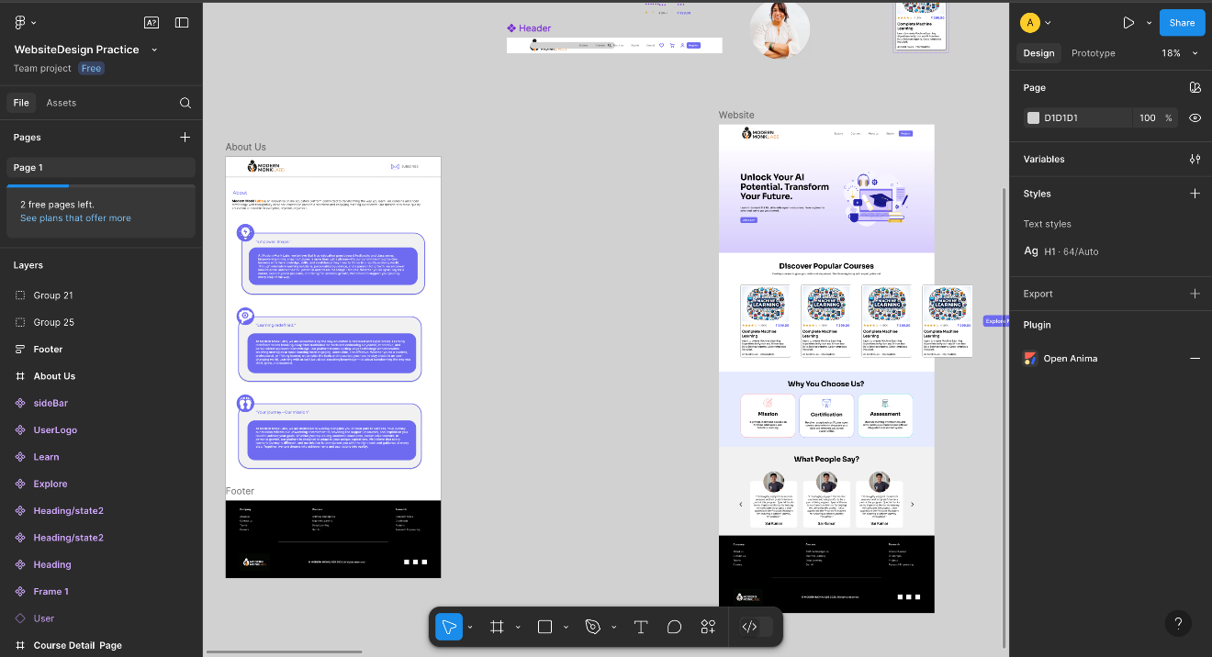Fig 1: Home Page and About us Page Design

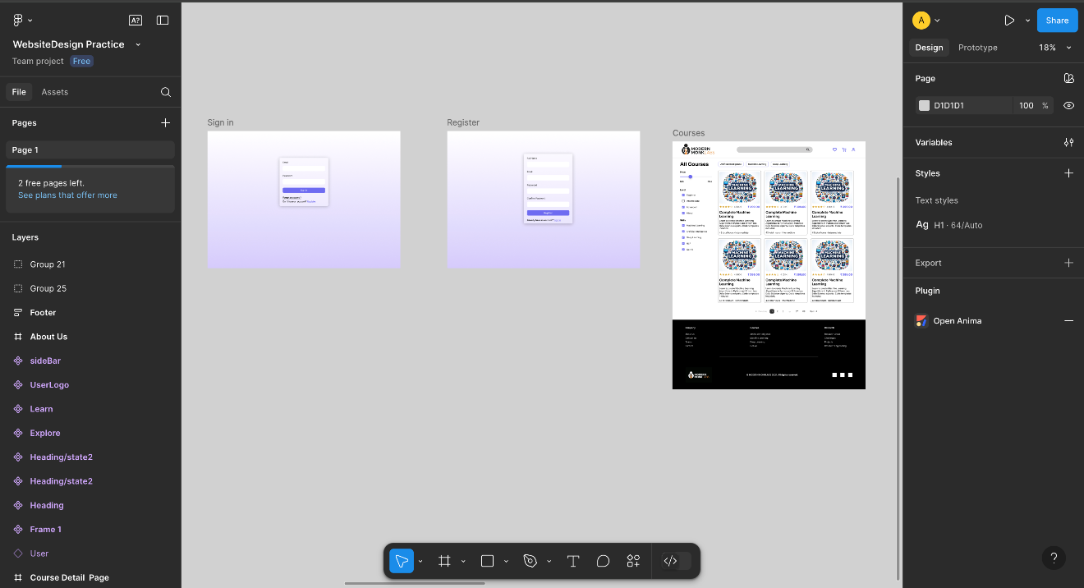 Fig 2: Sign up/Sign in page and Course List Page Design

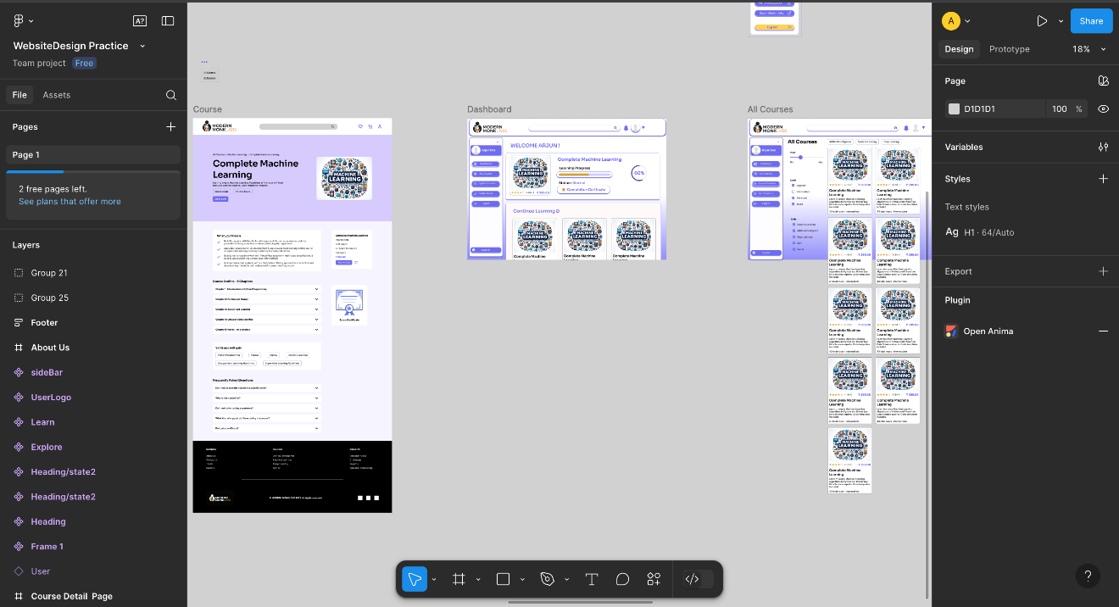

Fig 3: Course Content Page Design

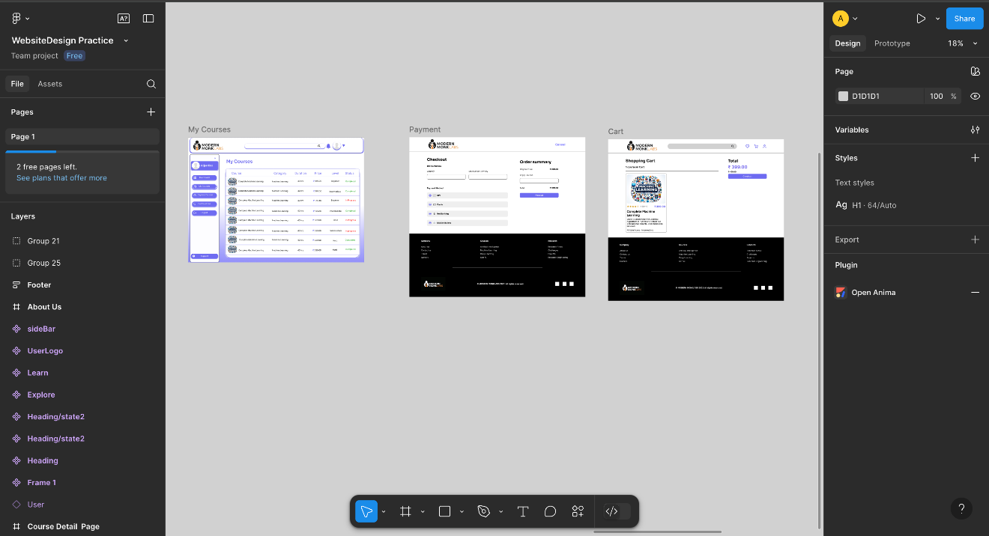

Fig 4: User Dashboard Page and Checkout Page Design

**Prototyping**

In Figma, prototyping involves creating interactive versions of one's designs, allowing one to simulate how a user might navigate through a product or application. This is achieved by connecting different screens (frames) and elements with interactions like clicks, hovers, or drags, enabling one to demonstrate the flow and behavior of the design without needing to write any code.

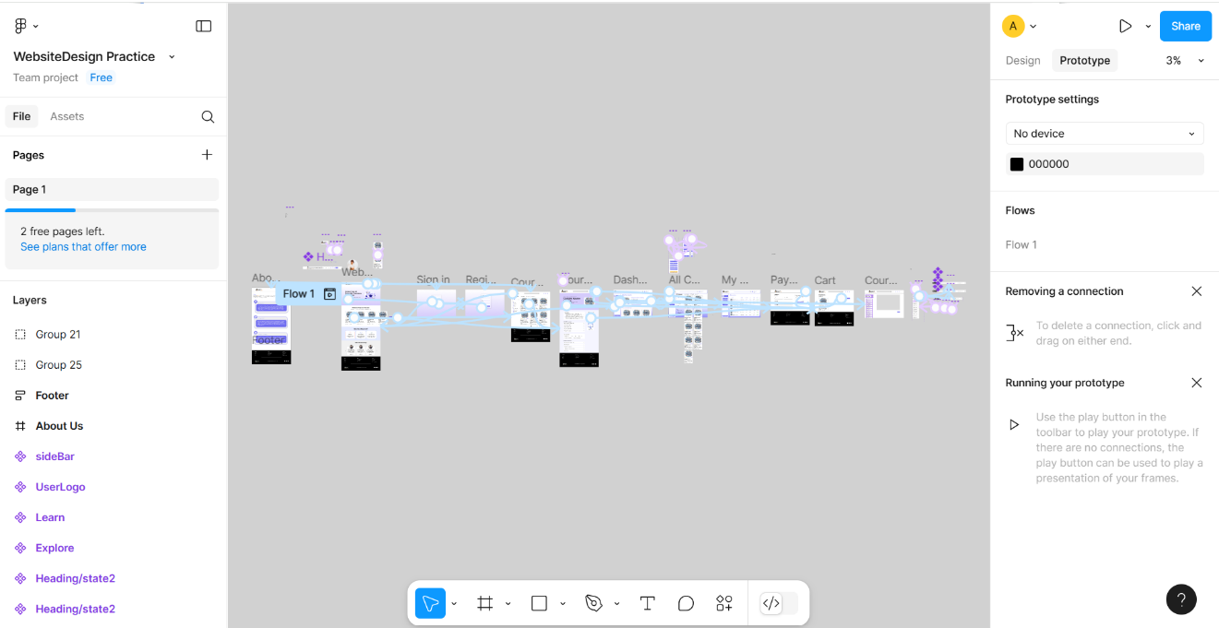

Fig 5: Design Prototype

**3.7.6. Development**

**Application Architecture**

The architecture follows a modular and component-driven approach using the App Router in Next.js. All pages are wrapped in a global layout defined in layout.tsx, which includes the authentication provider and the navigation bar. Each web page is composed of independent components such as HeroSection, TopCourses, Features, and Testimonials. Data is imported from local JSON files, enabling dynamic rendering and easy maintenance. Conditional navigation and user access control are enforced using local storage and Clerk’s session management.

The project follows a modular, component-driven architecture using Next.js App Router. The root layout wraps all content inside a ClerkProvider, which ensures user authentication flows seamlessly across pages. UI components are built as reusable elements, such as CourseCard, HeroSection, and Features. The architecture supports static generation for public pages and client-side interactivity for user-specific actions like course enrollment.

**Web Pages**

**Home Page**

The Home Page serves as the landing page of the LMS and is designed to capture user interest through visually engaging components. It begins with the Hero Section, featuring a motivational headline and a clear call-to-action button. The page then showcases top-rated courses in a carousel format, allowing users to browse popular options quickly. Additional sections include 'Why You Choose Us?' which outlines key platform advantages like certification and assessment features. The page concludes with a carousel of user testimonials, providing social proof and enhancing credibility.

The home page is the primary landing interface designed to engage visitors instantly. It includes:

* **Hero Section**: A visually bold introduction with a call-to-action button and marketing message "Unlock Your AI Potential. Transform Your Future."
* **Top Courses Carousel**: Dynamically displays top courses with key attributes like title, price, level, and ratings.
* **Features Section**: Highlights platform advantages such as certification, structured assessment, and clear learning goals.
* **Testimonials Section**: User feedback is displayed using a carousel format that includes reviewer names, images, and quotes.

Each of these components enhances user engagement and encourages exploration.

**Navbar and Layout**

The layout.tsx file serves as the backbone of the application's structure. It includes a ClerkProvider to ensure user session management across all routes. The Navbar component is fixed and includes navigation links to essential pages such as Home, Courses, About, Blog, and Contact. It supports responsive behaviour with a collapsible menu for mobile devices. The Navbar also integrates Clerk.js authentication components for sign-in, sign-up, and user profile management, adapting its content based on the user’s sign-in status.



Fig 6: Home Page

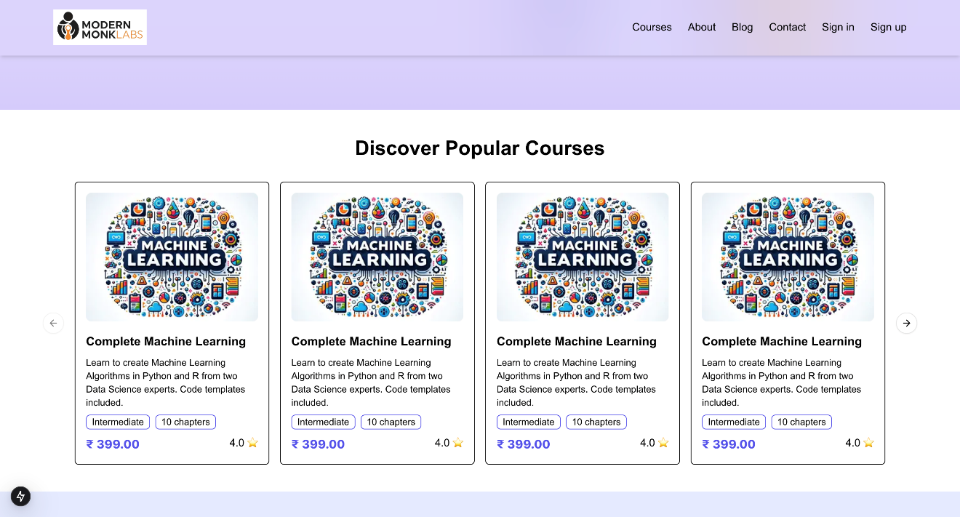

Fig 7: Course Section

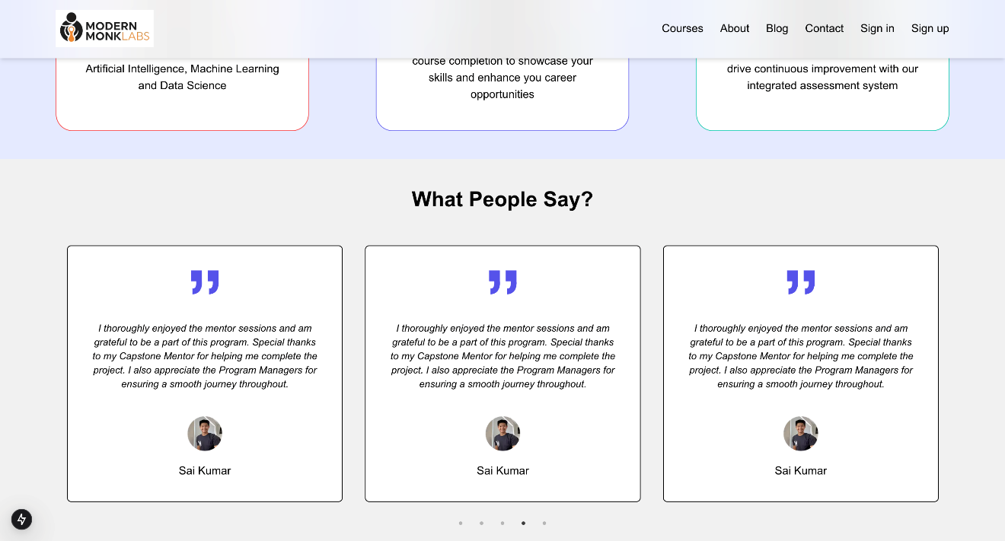

Fig 8: Testimonials

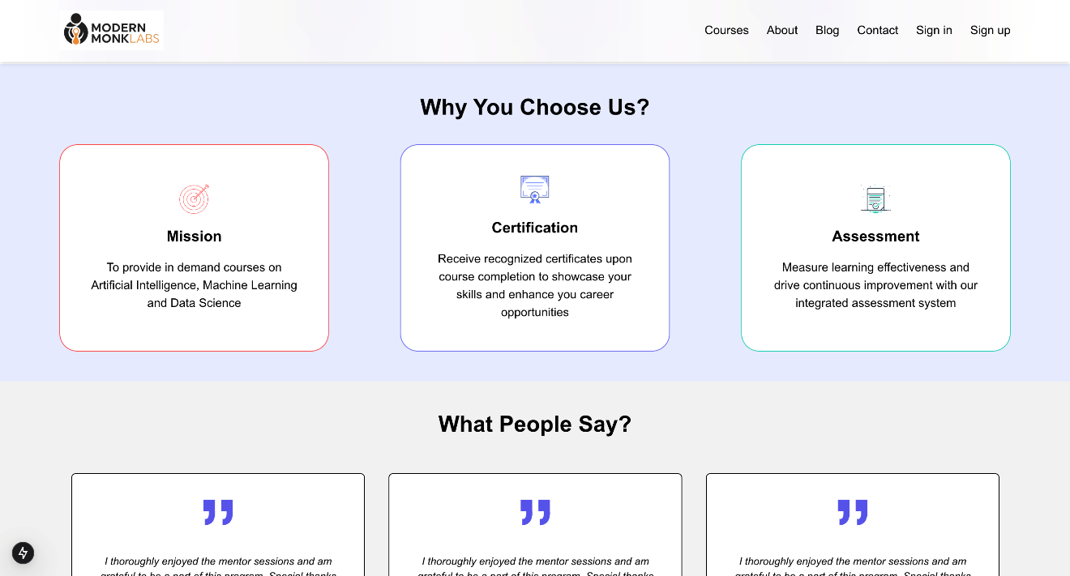

Fig 9: Features

**Authentication via Clerk.js**

Authentication is implemented using Clerk.js, a modern and user-friendly solution for managing user accounts. The Sign In and Sign Up components are conditionally rendered in the Navbar. When a user logs in, Clerk maintains the session using secure cookies and JWT tokens. The UserButton component provides access to the user profile and sign-out options. The authentication state is used in components like Course Card to determine whether to redirect users to the enrollment or course detail page.

Clerk.js manages user authentication:

* **Sign In / Sign Up Buttons** in the navigation bar
* **User Button** with profile and logout options when signed in
* Protected routes and components render conditionally
* Clerk handles secure session tokens and JWT under the hood

This ensures that only authenticated users can access certain routes like course content pages.

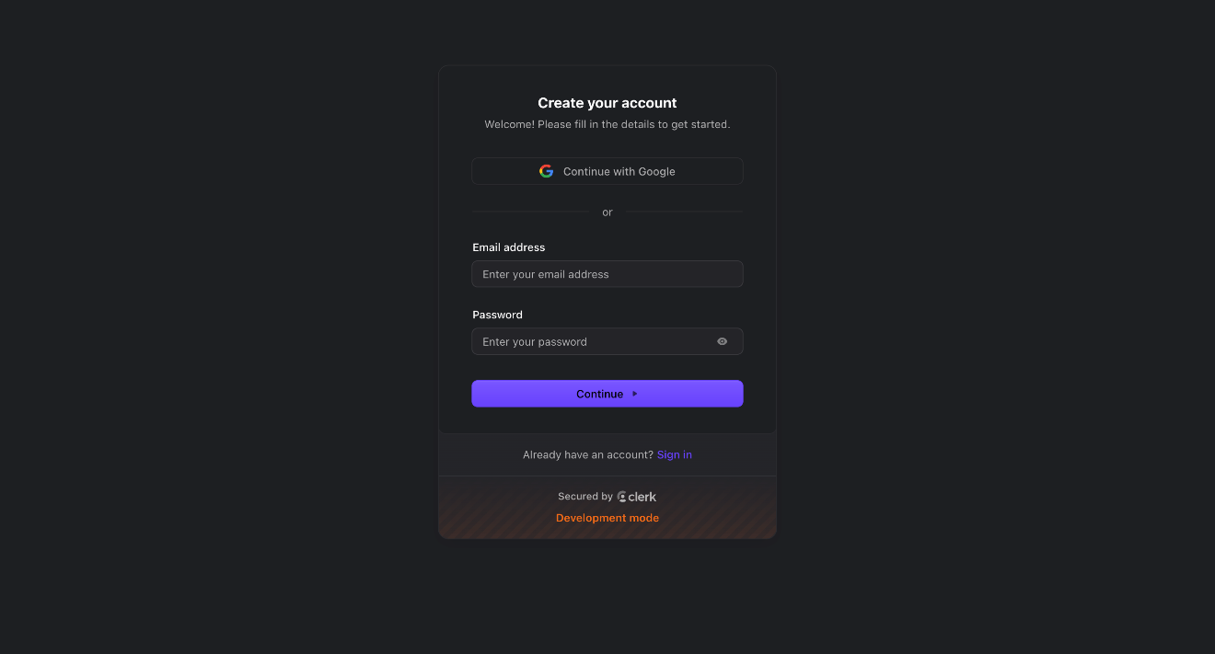

Fig 10: Sign up Page

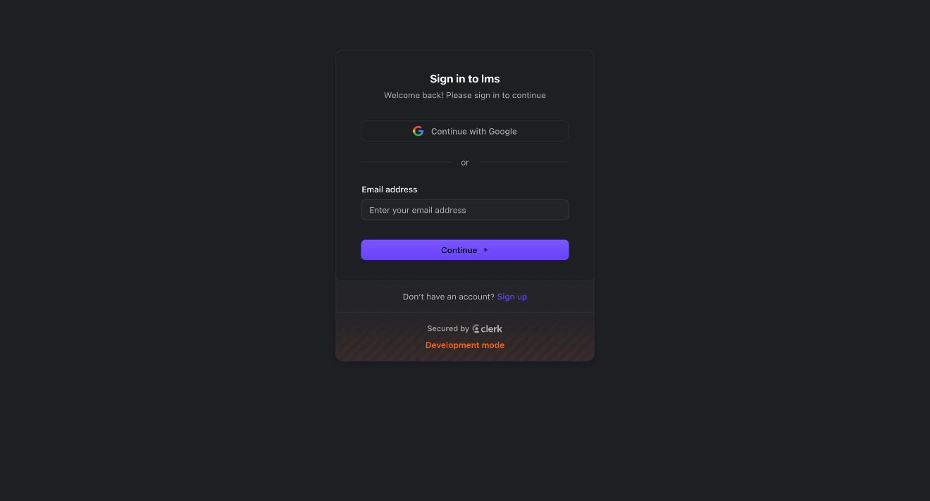

Fig 11: Sign in Page

**About Us Page**

The About Us page highlights the vision, mission, and team behind Modern Monk Labs. It uses a series of visually styled Card components to present this information in a structured and engaging format. The page includes three main sections: 'About Our Company', which describes the platform’s dedication to transformational education; 'Our Mission', which emphasizes the goal of empowering learners; and 'Meet Our Team', which

introduces the professionals driving the platform forward. This page not only builds trust but also helps users connect with the platform’s purpose.

This page explains the company's mission, values, and team through stylized Card components:

* **About Our Company**: Overview of Modern Monk Labs' philosophy
* **Our Mission**: Focus on education, empowerment, and innovation
* **Meet Our Team**: Description of the passionate team behind the platform

The design is user-friendly and consistent with the rest of the application’s branding.

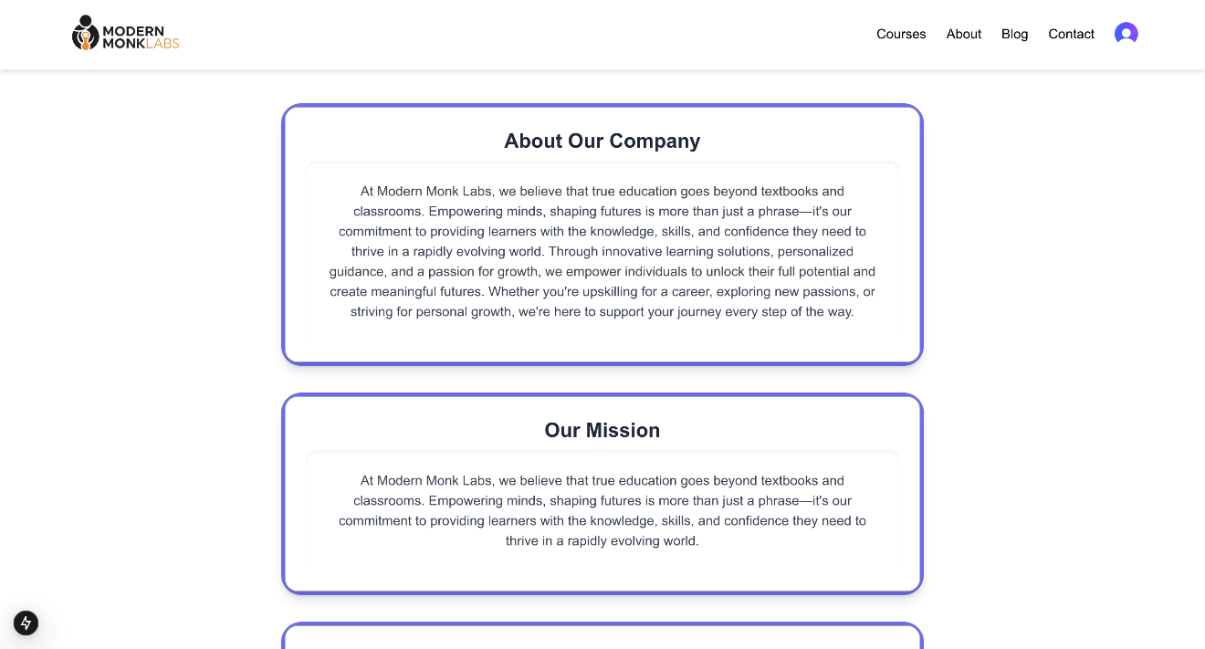

Fig 12: About us Page

**Course List Page**

The Course List page aggregates and displays all available courses using structured course data defined in a JSON-like array within `courses.tsx`. Each course object includes attributes such as title, description, level, price, duration, and image path. The list supports scalability, allowing easy addition or modification of courses without altering the display logic. This page acts as a catalog for all learning materials offered by the LMS, enabling users to browse based on their interests and skill levels.

Courses are displayed from a local data file courses.tsx, containing fields like:

* Title
* Description
* Price
* Level
* Duration
* Image

These courses are displayed in a grid layout, each rendered using the CourseCard component. This design allows easy navigation and scalability as more courses are added.

**Course Card Component**

The CourseCard component is a reusable UI block that encapsulates the logic and design of each individual course tile. It displays the course's image, title, difficulty level, duration, and price. The component uses Next.js routing to determine where a user should be navigated based on their enrollment status. This logic is implemented using the `useRouter` hook and localStorage checks. If the user is already enrolled in the course, they are taken directly to the course detail page. Otherwise, they are redirected to the enrollment page. This design provides a seamless user experience.

CourseCard.tsx dynamically renders course details and handles navigation logic:

* On click, it checks localStorage for enrollment status (enrolled_<id>)
* If enrolled, redirects to /course/{id}
* Else, redirects to /EnrollPage/{id}

Each card displays:

* Image
* Title
* Difficulty level
* Duration
* Price

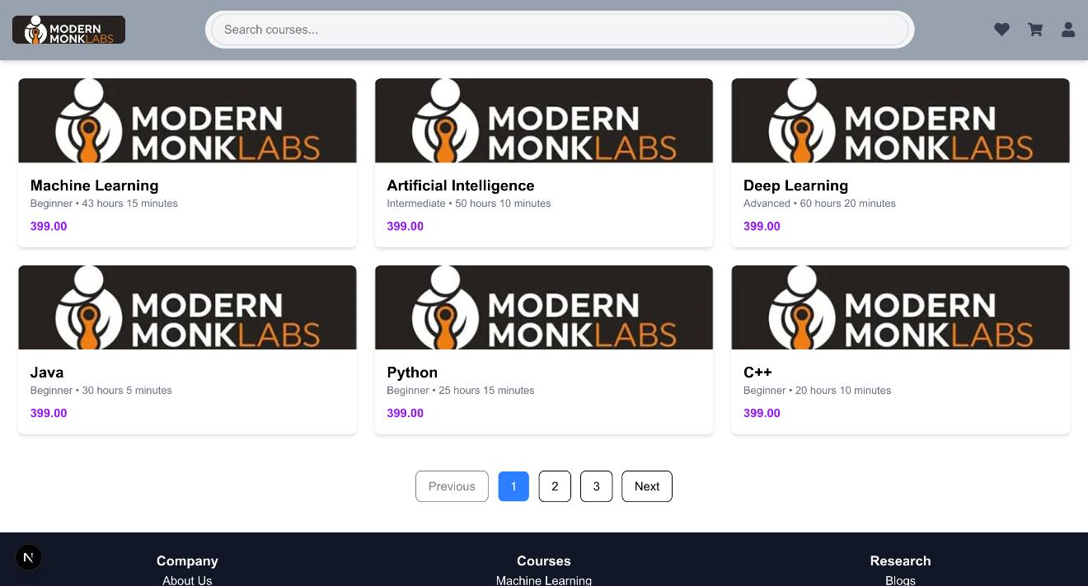

Fig 13: Course list page

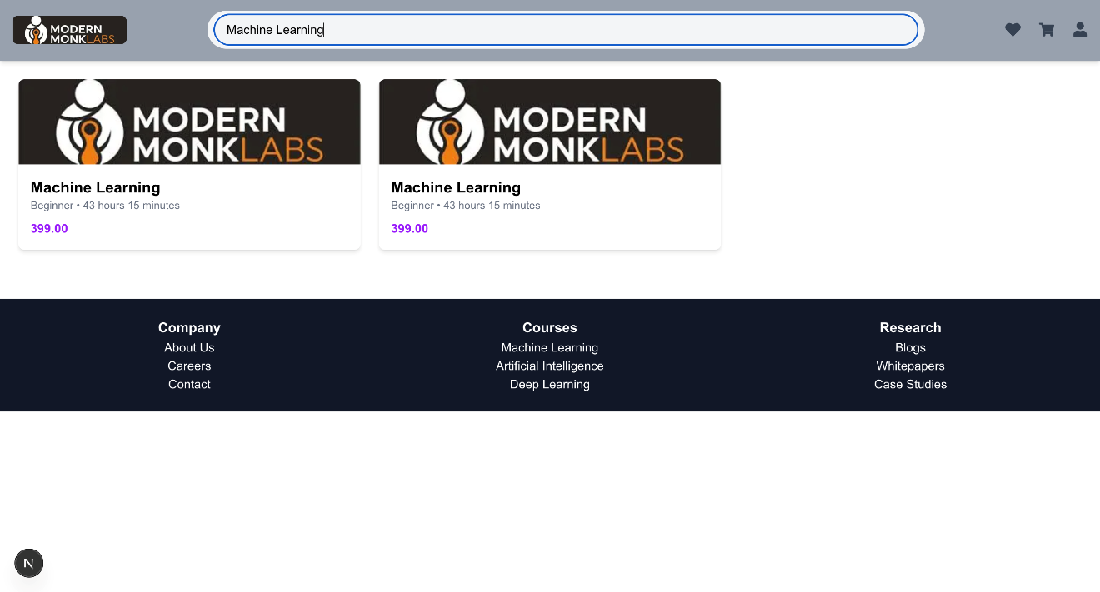

Fig 14: Search Functionality

**Course Enrollment Logic**

Enrollment logic in the application is currently handled on the client side using localStorage. Each course card checks if a key formatted as `enrolled_{id}` is set to 'true'. If so, the user is considered enrolled and gets access to the course content. Otherwise, they are guided through an enrollment flow. Although this is a placeholder for demonstration purposes, it lays the foundation for future enhancements involving persistent user-course mappings through backend services and databases.

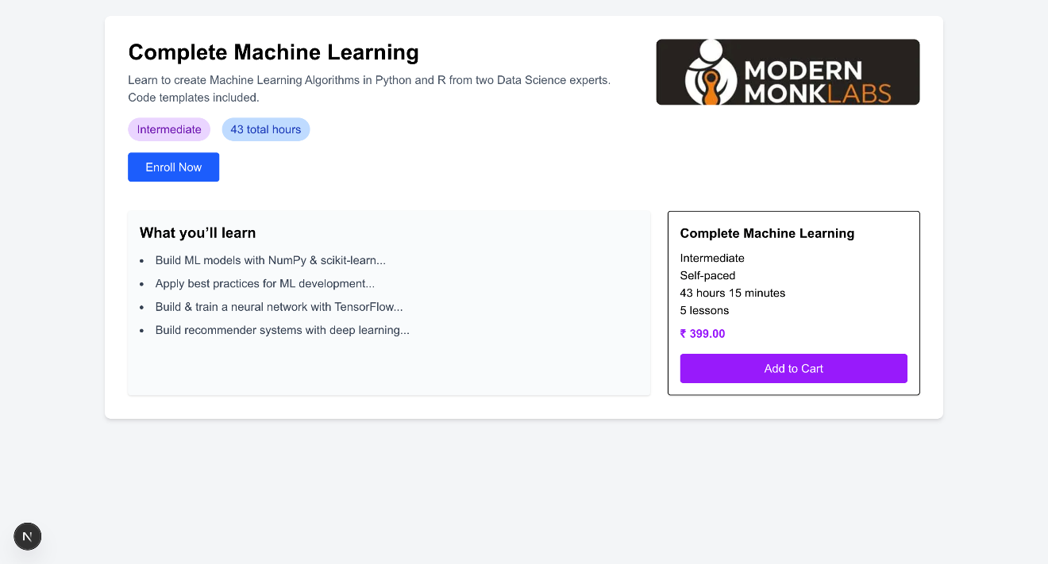

Fig 15: Course Enrollment Page

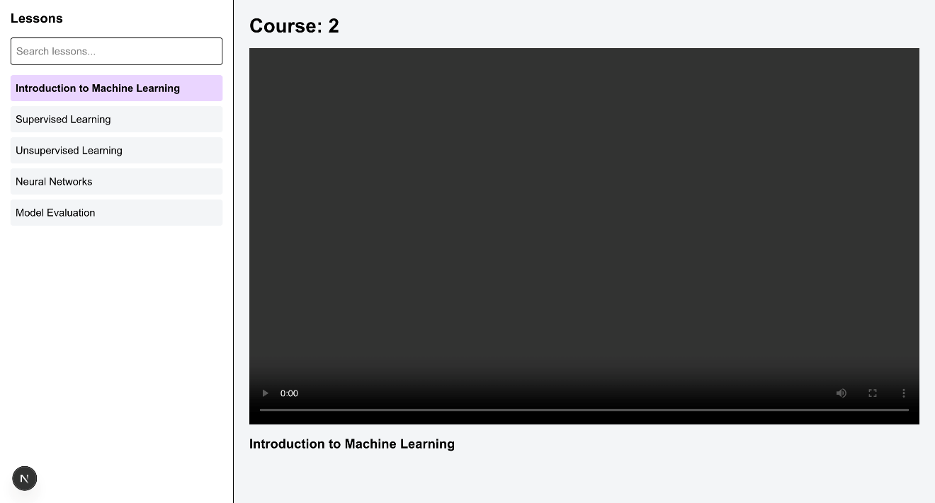

Fig 16: Course Media Page

**Responsive Design Considerations**

Responsiveness is a critical aspect of this LMS platform. All components, from navigation to carousels and course cards, are built with Tailwind CSS, ensuring that the layout adapts seamlessly across various screen sizes and devices. The design has been tested for breakpoints ranging from mobile phones to large desktops. Media queries, flexbox grids, and dynamic sizing have been employed to maintain visual consistency and usability across resolutions.

**User Experience Enhancements**

Several design and functional choices enhance the overall user experience. These include hover animations, button transitions, carousel autoplay, and intuitive routing. The platform also uses tooltips and consistent UI feedback to guide user interaction. Loading speeds are optimized through Next.js image components, lazy loading, and modular imports, ensuring a fast and fluid experience. Conditional rendering based on authentication state improves personalization and accessibility.

**Security and Access Control**

Security is enforced at both the UI and session levels using Clerk.js. Clerk provides secure authentication mechanisms including session tokens, protected routes, and user state checks. Although course access is currently simulated with localStorage, future plans involve transitioning to server-side validation with role-based access control. Sensitive operations and content will be safeguarded using JWT authentication, database validation, and server middleware to ensure secure data delivery.

**Future Enhancements**

To evolve into a fully-fledged LMS platform, several enhancements are planned:

* Integration with a backend database (e.g., MongoDB, Firebase)
* Payment gateway support for paid course access
* Progress tracking and analytics dashboards
* Admin/instructor panel for content management
* Interactive elements like live chat, forums, and assignments

**ACTIVITY LOG FOR THE WEEK**

|  |  |  |  |
| --- | --- | --- | --- |
| **Weeks** | **Description of the weekly activity** | **Learning Outcome** | **Person In- Charge Signature** |
| Week–1 | Initial Project planning and Team Formation | Understood the project scope, roles and responsibilities |  |
| Week-2 | Requirement gathering for the Learning Management System | Gained skills in stakeholder communication and requirement elicitation |  |
| Week-3 | Analyzed the requirements and created use case diagrams | Learnt how to convert raw requirements into structured use cases |  |
| Week-4 | Designed the Low-fidelity Wireframes for the Learning Management System using Figma design tool | Understood how to create Low-fidelity Wireframes using Figma design tool |  |
| Week-5 | Converted Low-fidelity Wireframes into High-fidelity Wireframes using Figma design tool | Understood how to create High-fidelity Wireframes using Figma design tool |  |
| Week-6 | Converted the Wireframes into actual design using Figma design tool. Designed home page, Sign in/Sign up page, Courses Page of Learning Management System. | Learnt how to design different components of a website in Figma |  |
| Week-7 | Designed Course Content page, Check out Page, About us Page of Learning Management System | Understood key concepts like Adding frames, formatting text, creating components for reusability, adding grid lines |  |
| Week-8 | Linking all the pages of Learning Management System using prototype in Figma | Learnt how to link different pages using prototyping and how to add transitions |  |
| Week-9 | Started development phase of the project. Developed the home page of Learning Management System | Gained hands-on knowledge on HTML, Tailwind CSS, JavaScript |  |
| Week-10 | Implemented User Authentication and Authorization modules for Learning Management System | Learnt secured login system using clerk.js |  |
| Week-11 | Built a user dashboard where the user can update the details and change the password | Learnt how to send the verification email to the user to change the password |  |
| Week-12 | Developed the about us page and course listing page for Learning Management System | Learnt how to implement search functionality and pagination |  |
| Week-13 | Developed the about us page and course listing page for Learning Management System | Learnt how to implement search functionality and pagination |  |

|  |  |  |  |
| --- | --- | --- | --- |
| Week-14 | Developed the course content page for each course | Learnt how Next.js uses folder structure to navigate through different web pages of the application |  |
| Week-15 | Added chapters and video content for each course in Learning Management System | Understood media management and integration in LMS |  |
| Week-16 | Performed Integration testing and fixed bugs in Learning Management System | Enhanced debugging and system integration testing skills |  |

**5. CONCLUSION**

The internship at **Modern MonkLabs** offered a valuable opportunity to apply theoretical knowledge in a real-world setting through the development of a **Learning Management System (LMS)**. It provided hands-on experience in full-stack web development and helped build both technical and soft skills.

**Technical Learning Summary**

I gained practical experience in using **HTML, CSS, JavaScript, React.js, Next.js, Tailwind CSS, Node.js (via API routes), and MongoDB**. Each module focused on a specific technology and its role in the development of the LMS. From building UI components to managing backend logic and database interactions, I learned how to structure a full-stack application effectively.

**Project Summary and Contributions**

The LMS project involved creating core features such as the **home page**, **authentication system**, **course catalog**, **dashboard**, and **enrollment flow**. I worked on building dynamic pages, handling data through APIs, and designing responsive layouts based on Figma mockups. My contributions included both frontend and backend functionality, integrated seamlessly through Next.js.

**Learning Outcomes**

Through this project, I learned how to:

* Build reusable frontend components
* Implement secure user login and dashboard systems
* Fetch and manipulate data using APIs
* Use Tailwind CSS for responsive and clean layouts
* Deploy and test applications in a real-time environment

**REFERENCES**

1. <https://reactjs.org/docs/getting-started.html>
2. <https://nextjs.org/docs>
3. <https://tailwindcss.com/docs>
4. <https://developer.mozilla.org/en-US/docs/Web/HTML>
5. <https://developer.mozilla.org/en-US/docs/Web/CSS>
6. <https://developer.mozilla.org/en-US/docs/Web/JavaScript>
7. <https://nodejs.org/en/docs/>
8. <https://www.mongodb.com/docs/>
9. <https://mongoosejs.com/docs/>
10. https://jwt.io/introduction